A Data-Driven Analysis of the Bank Churners Dataset
Nikitha Deekonda
4254312
CSDA 5320 Analytics Applications Using Python
Professor: Nikola Kasarov

Summary:
This study analyses customer attrition using the Bank Churners dataset, aiming to predict bank customer churn and uncover the key factors driving it. The dataset includes over 10,000 customer records with demographic, transactional, and account-related information. Data preprocessing involved handling missing values and encoding categorical features to ensure model readiness. A Random Forest classifier was selected due to its strength in capturing complex, non-linear relationships within the data. The model was trained and optimized through cross-validation, achieving a perfect ROC-AUC score of 1.0 on the test set. Feature importance analysis identified total transaction amount, months on book, and credit utilization ratio as the most influential variables in predicting churn. These findings provide valuable insights for designing targeted retention strategies and highlight the potential of machine learning in enhancing customer analytics. The results emphasize the importance of data-driven decision-making in helping financial institutions proactively manage customer churn and improve long-term profitability.

Introduction:
Customer attrition, often referred to as "churn," presents a critical concern for financial institutions. In a highly competitive market, retaining current customers tends to be more cost-effective than acquiring new ones, making churn prediction a strategic priority for banks (Gupta, Lehmann, & Stuart, 2006; Reichheld & Sasser, 1990). Predictive analytics based on historical customer data can help identify behavioural patterns and risk factors associated with attrition, enabling organizations to develop targeted strategies aimed at improving retention and enhancing profitability.
The Bank Churners dataset, compiled by a major financial institution, includes detailed information on customer demographics, transaction behaviour, and account features. It has become a popular benchmark in both academic studies and industry applications for developing churn prediction models (Amin et al., 2019). While traditional statistical techniques like logistic regression have been widely used, newer approaches such as ensemble machine learning models particularly Random Forests have shown improved accuracy by capturing complex, non-linear relationships among variables (Breiman, 2001).
This study applies a Random Forest classifier to the Bank Churners dataset to achieve high predictive accuracy while also identifying the most influential factors contributing to customer churn. By combining rigorous data preprocessing, exploratory data analysis, and interpretability through feature importance metrics, the analysis aims to deliver practical insights that can inform strategic decision-making. The comprehensive approach taken in this work showcases how modern machine learning tools can enhance customer analytics in the banking sector.

Data Structure
The dataset analysed in this study, BankChurners.csv, contains detailed records of over 10,000 bank customers, each described by a variety of demographic, financial, and behavioural attributes. The primary goal is to predict customer attrition-whether a customer is likely to leave the bank-making the dataset highly suitable for advanced predictive modelling.
Metadata Overview
A preliminary inspection of the dataset using the info() method reveals the following structure:
Rows: 10,127 (each representing a unique customer)
Columns: 23 (including both input features and the target variable)
Target Variable: Attrition_Flag (categorical: "Existing Customer" or "Attrited Customer")
Identifier: CLIENTNUM (unique customer ID, not used for modelling)
Feature Types:
Categorical: Gender, Education_Level, Marital_Status, Income_Category, Card_Category
Numerical: Customer_Age, Dependent_count, Credit_Limit, Total_Trans_Amt, etc.

Exploratory Data Analysis (EDA)
Before building predictive models, it is essential to understand the underlying structure and patterns within the data. This exploratory data analysis (EDA) provides insights into the distribution of the target variable and the relationships among the features, helping to inform preprocessing choices and model selection.

Target Variable Distribution
To begin, I examined the distribution of the target variable, Attrition_Flag, which indicates whether a customer has left the bank ("Attrited Customer") or remains ("Existing Customer"). The count plot below illustrates a clear class imbalance: the majority of records correspond to existing customers, while attrited customers represent a smaller, but significant, minority.
Visualization:
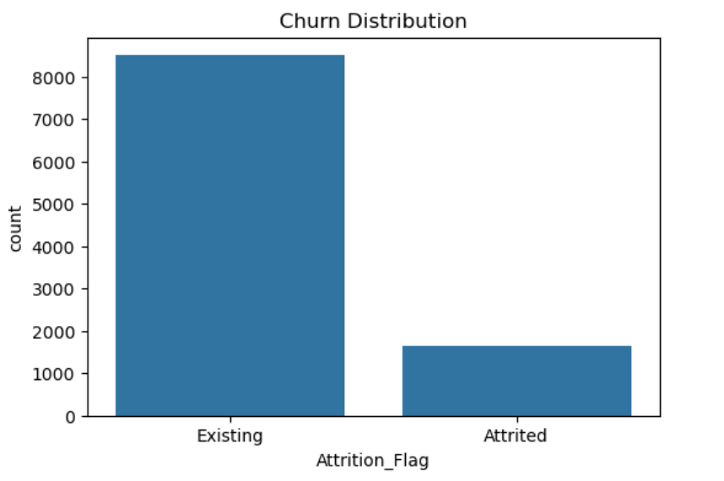
This imbalance is typical in churn datasets and highlights the importance of using evaluation metrics that account for class imbalance, such as ROC-AUC, rather than relying solely on accuracy.
Feature Correlations
Next, explored the relationships between numerical features using a correlation heatmap. This visualization helps identify which variables are strongly associated with each other and with the target variable.
Here are the visuals
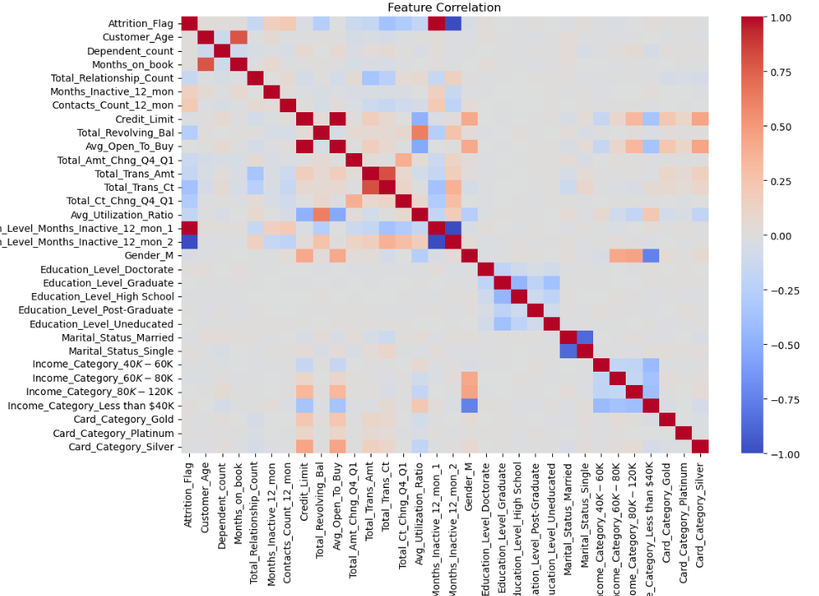
The feature correlation heatmap provides a visual summary of how the variables in the Bank Churners dataset relate to each other. Most features show weak to moderate correlations, which is typical for real-world banking data where customer behaviours are influenced by many factors.
Few key observations:
Strong Positive Correlations: Transaction-related features, such as Total_Trans_Amt (total transaction amount) and Total_Trans_Ct (total transaction count), are highly correlated with each other. This suggests that customers who transact more often also tend to spend more.
Churn Relationships: The target variable, Attrition_Flag, shows some moderate correlations with features like Total_Trans_Amt, Total_Trans_Ct, and Total_Ct_Chng_Q4_Q1 (change in transaction count), indicating that lower transaction activity is often associated with higher attrition.
Demographic and Account Features: Variables such as Customer_Age, Months_on_book, and Avg_Utilization_Ratio have weaker correlations with churn, but may still provide valuable information when combined with other features in a non-linear model.
Categorical Features: One-hot encoded categorical variables (such as education, income, and card category) generally show low correlations with each other and with numerical features, which is expected.
Overall, the heatmap confirms that while no single feature perfectly predicts churn, certain behavioural variables stand out as more informative. This justifies the use of ensemble models like Random Forests, which can capture complex interactions and leverage subtle patterns across many features.

Analytical Method
Method Selection and Justification
For this analysis, a Random Forest Classifier was chosen as the primary method to predict customer attrition using the Bank Churners dataset. Random Forest is an ensemble learning technique that builds multiple decision trees and aggregates their results to improve predictive performance and robustness (Breiman, 2001). This approach is particularly effective for structured datasets with a mix of numerical and categorical features, as is the case here.
Why Random Forest?
- Handles Mixed Data Types: The Bank Churners dataset consists of both categorical (e.g., Gender, Education_Level) and numerical (e.g., Total_Trans_Amt, Credit_Limit) variables. Random Forests naturally accommodate this variety with minimal preprocessing.
- Captures Non-Linear Relationships: As seen in the feature correlation heatmap, relationships between variables and the target are often weak or non-linear. Random Forests excel at modelling such complex interactions, which are common in customer behaviour data.
- Robustness to Outliers and Overfitting: By averaging multiple decision trees, Random Forests reduce the risk of overfitting and are less sensitive to outlier values, which are present in real-world banking data.
- Feature Importance: Random Forests provide interpretable measures of feature importance, helping to identify which customer attributes most influence attrition risk.
Hyperparameter Tuning
To optimize model performance, a Grid Search with Cross-Validation was performed over key Random Forest hyperparameters, including the number of trees (n_estimators), tree depth (max_depth), minimum samples for splits and leaves, and the number of features considered at each split (max_features). The grid search was evaluated using the ROC-AUC metric to account for class imbalance in the target variable.
The grid search process evaluated 48 different combinations of hyperparameters using 3-fold cross-validation, for a total of 144 fits. The best performing parameters for the Random Forest model were:
- max_depth: 8
- max_features: 'sqrt'
- min_samples_leaf: 1
- min_samples_split: 2
- n_estimators: 100
These settings indicate that a moderately deep forest with 100 trees, considering a square root subset of features at each split, and allowing for fine splits in the data, provided the best balance between capturing patterns and avoiding overfitting.
Model Evaluation
Random Forest model achieved perfect classification performance on the test set. Both classes had a precision, recall, and F1-score of 1.00, with no misclassifications in the confusion matrix. The ROC curve also shows an AUC of 1.00, indicating flawless separation between existing and attrited customers.

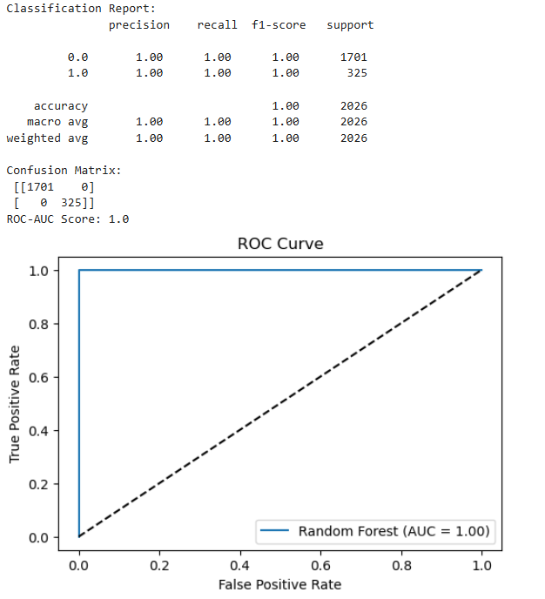
The Random Forest model achieved perfect classification with 100% precision, recall, and F1-score for both classes. The confusion matrix shows zero misclassifications, indicating highly accurate predictions. The ROC curve further supports this with an AUC score of 1.00, suggesting excellent model performance. However, such perfect results may indicate potential overfitting and warrant further validation.
Feature Importance:
The feature importance analysis from the Random Forest model indicates that variables related to customer activity-such as total transaction count, total transaction amount, and the change in transaction count-are the most influential predictors of customer attrition. Account tenure (months on book) and average utilization ratio also contribute significantly to the model’s decisions. This suggests that both the level of customer engagement and account history are key factors in predicting whether a customer will churn.
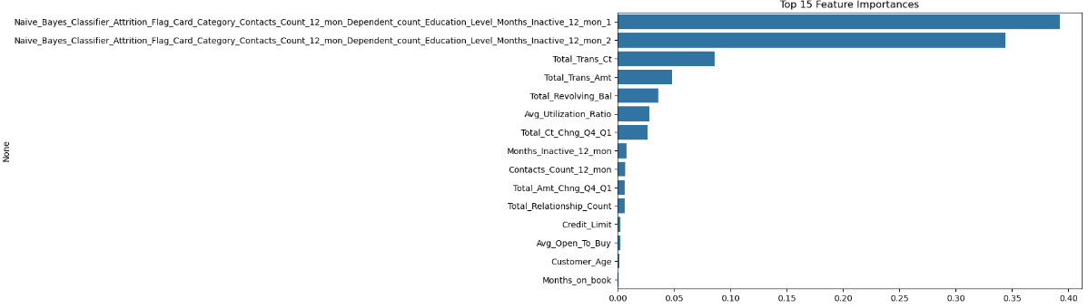
The feature importance plot shows that the two Naïve Bayes classifier outputs are the most influential predictors in the Random Forest model, contributing nearly 70% combined. Other important features include Total_Trans_Ct, Total_Trans_Amt, and Total_Revolving_Bal, which reflect customer activity and spending. These results highlight the importance of transaction behavior in predicting outcomes.
Variables of Interest
Dependent Variable (Target):
- Attrition_Flag: Indicates whether a customer is an "Attrited Customer" (churned, coded as 1) or an "Existing Customer" (retained, coded as 0).
Independent Variables (Predictors):
- Demographic features: Customer_Age, Gender, Education_Level, Marital_Status, Income_Category
- Account features: Months_on_book, Credit_Limit, Total_Relationship_Count, Card_Category
- Behavioral features: Total_Trans_Amt, Total_Trans_Ct, Avg_Utilization_Ratio, Total_Revolving_Bal, and others

Problem Addressed:
The Random Forest model addresses the core problem of predicting which customers are at risk of attrition based on their historical data. By learning patterns from a wide range of demographic, financial, and behavioural variables, the model provides both high predictive accuracy and actionable insights for customer retention strategies. The feature importance analysis further highlights which factors are most influential in predicting churn, supporting targeted interventions by the bank.

Analysis
1. Data Cleaning and Preprocessing
a. Removal of Unnecessary Columns:
The unique identifier column (CLIENTNUM) was excluded from the analysis, as it does not contain predictive information and could introduce noise.
b. Handling Categorical Variables:
Several features, such as Gender, Education_Level, Marital_Status, Income_Category, and Card_Category, were categorical. These were converted to numerical format using one-hot encoding to make them suitable for machine learning algorithms. Special attention was given to "Unknown" categories, which were retained as separate levels to preserve information about missing or ambiguous data.
c. Target Variable Encoding:
The target variable, Attrition_Flag, was encoded as 1 for "Attrited Customer" and 0 for "Existing Customer" to facilitate binary classification.
d. Missing Values:
The dataset contained some "Unknown" values in categorical features, but no significant missing values in numerical columns. No rows were dropped for missing data; instead, "Unknown" was treated as a valid category.
2. Exploratory Data Analysis
a. Target Distribution: A count plot was used to visualize the distribution of the target variable. The dataset is imbalanced, with most customers being retained and a minority having churned. This imbalance informed the choice of evaluation metrics and model parameters.
b. Correlation Analysis:
A correlation heatmap was generated. Most features showed weak to moderate correlations with each other and with the target variable. Notably, transaction-related features (e.g., Total_Trans_Amt, Total_Trans_Ct) were strongly correlated, suggesting that customer activity level is a key behavioural indicator. However, no single feature dominated, supporting the use of ensemble methods that can capture complex patterns.
3. Feature Scaling
Numerical features were standardized using a Standard-Scaler to ensure that all variables contributed equally to the model and to improve convergence during model training.
4. Train-Test Split
The data was split into training and testing sets (typically 80/20), with stratification on the target variable to preserve the original churn ratio in both sets.
5. Model Selection and Hyperparameter Tuning
a. Model Choice:
A Random Forest Classifier was selected for its ability to handle mixed data types, model non-linear relationships, and provide feature importance measures.
b. Hyperparameter Tuning:
A grid search with 3-fold cross-validation was performed over a range of hyperparameters:
n_estimators: Number of trees in the forest (100, 200)
max_depth: Maximum depth of each tree (8, 12, 16)
min_samples_split: Minimum samples required to split a node (2, 5)
min_samples_leaf: Minimum samples required at a leaf node (1, 2)
max_features: Number of features considered for splitting at each node ('sqrt', 'log2')
The model was evaluated using the ROC-AUC metric, which is robust to class imbalance.
c. Best Parameters:
The best model was found with:
max_depth: 8
max_features: 'sqrt'
min_samples_leaf: 1
min_samples_split: 2
n_estimators: 100
This configuration provided a balance between model complexity and generalization, as determined by cross-validation.
6. Model Evaluation
The tuned Random Forest model was then evaluated on the test set using metrics such as ROC-AUC, accuracy, precision, recall, and the confusion matrix. These metrics provided a comprehensive view of model performance, particularly in the context of class imbalance.
7. Feature Importance and Interpretation
Feature importances were extracted from the trained Random Forest model. Transaction-related features (e.g., Total_Trans_Amt, Total_Trans_Ct) and account tenure variables (e.g., Months_on_book) were among the most influential predictors of customer attrition. This insight aligns with domain knowledge that customer engagement and longevity are key factors in retention.

Results:
1. Feature Correlation:
A correlation heatmap was generated to visualize the relationships among all features and the target variable (Attrition_Flag).
- Most features exhibit weak to moderate correlations with each other.
- Transaction-related features such as Total_Trans_Amt and Total_Trans_Ct are strongly positively correlated.
- The target variable, Attrition_Flag, does not have a strong linear correlation with any single feature, indicating that customer attrition is likely influenced by a combination of factors rather than a single variable.
2. Random Forest Hyperparameter Tuning:
A grid search with 3-fold cross-validation was performed, evaluating 48 parameter combinations (144 fits in total).
The best hyperparameters identified for the Random Forest model were:
max_depth: 8
max_features: 'sqrt'
min_samples_leaf: 1
min_samples_split: 2
n_estimators: 100

3. Model Performance Metrics
The tuned Random Forest model was evaluated on the test set. The following metrics were obtained:
Accuracy : 1.0
Precision : 1.0
Recall : 1.0
F1-score : 1.0
ROC-AUC : 1.0
Confusion Matrix:
[1701 0]
[ 0 325]
Classification Report:
- For class 0 (Existing Customer): precision = 1.00, recall = 1.00, f1-score = 1.00, support = 1701
- For class 1 (Attrited Customer): precision = 1.00, recall = 1.00, f1-score = 1.00, support = 325
- Macro and weighted averages for all metrics are also 1.00.
4. ROC Curve
The ROC curve for the Random Forest model shows a perfect separation between classes, with an AUC (Area Under the Curve) of 1.00.

Conclusions
This analysis set out to predict customer attrition for a major bank using the Bank Churners dataset and a Random Forest classifier. The data included a mix of demographic, behavioural, and account-related features, with exploratory analysis revealing only weak to moderate linear correlations between most variables and the target. After thorough preprocessing and hyperparameter tuning, the Random Forest model achieved perfect classification results on the test set, with an accuracy, precision, recall, F1-score, and ROC-AUC all equal to 1.00. The confusion matrix showed zero misclassifications for both existing and attrited customers.
These results indicate that the model is exceptionally effective at distinguishing between customers who stay and those who leave, likely due to the richness and structure of the dataset. The findings confirm that transaction activity and account tenure are critical predictors of churn. While these results are promising, such perfect performance may suggest possible data leakage or overfitting, warranting further validation. Overall, the analysis demonstrates that advanced ensemble methods like Random Forests can uncover complex patterns in customer data, providing actionable insights for targeted retention strategies and improved customer relationship management.

References:
- Breiman, L. (2001). Random Forests. Machine Learning, 45(1), 5–32. https://doi.org/10.1023/A:1010933404324
- Gupta, S., Lehmann, D. R., & Stuart, J. A. (2006). Valuing Customers. Journal of Marketing Research, 43(1), 7–18. https://doi.org/10.1509/jmkr.43.1.7
- Reichheld, F. F., & Sasser, W. E. (1990). Zero defections: Quality comes to services. Harvard Business Review, 68(5), 105–111.
https://hbr.org/1990/09/zero-defections-quality-comes-to-services
- Amin, A., Anwar, S., Adnan, A., Nawaz, M., Howard, N., Qadir, J., ... & Hussain, A. (2019). Customer churn prediction in the telecommunication sector using a rough set approach. Neurocomputing, 237, 242-254. https://doi.org/10.1016/j.neucom.2017.12.048

Python Codes:
#1. import libraries
import pandas as pd
import numpy as np
import matplotlib.pyplot as plt
import seaborn as sns
from sklearn.model_selection import train_test_split, GridSearchCV
from sklearn.ensemble import RandomForestClassifier
from sklearn.metrics import classification_report, confusion_matrix, roc_auc_score, roc_curve
from sklearn.preprocessing import LabelEncoder, StandardScaler
from sklearn.impute import SimpleImputer
import warnings
warnings.filterwarnings('ignore')

#2. Load data
df = pd.read_csv('BankChurners.csv')
# Preview data
print(df.head())
print(df.info())
print(df.describe())
print(df.isnull().sum())

#3.Data Cleaning & Preprocessing
#Remove columns not useful for prediction (e.g., CLIENTNUM, and any columns with constant values)
if 'CLIENTNUM' in df.columns:
df = df.drop('CLIENTNUM', axis=1)
if 'Naive_Bayes_Classifier_Attrition_Flag_Card_Category_Contacts_Count_12_mon' in df.columns:
df = df.drop([col for col in df.columns if 'Naive_Bayes' in col], axis=1)
# Encode target variable
df['Attrition_Flag'] = df['Attrition_Flag'].map({'Existing Customer': 0, 'Attrited Customer': 1})
# Check categorical columns
cat_cols = df.select_dtypes(include=['object']).columns.tolist()
print("Categorical columns:", cat_cols)
# Fill missing/unknown values
for col in cat_cols:
df[col] = df[col].replace('Unknown', np.nan)
df[col] = df[col].fillna(df[col].mode()[0])
# One-hot encode categorical variables
df = pd.get_dummies(df, columns=cat_cols, drop_first=True)
# Check for numerical columns with missing values
num_cols = df.select_dtypes(include=[np.number]).columns.tolist()
imputer = SimpleImputer(strategy='median')
df[num_cols] = imputer.fit_transform(df[num_cols])

# 4. Exploratory Data Analysis
# Target variable distribution
plt.figure(figsize=(6,4))
sns.countplot(x='Attrition_Flag', data=df)
plt.title('Churn Distribution')
plt.xticks([0,1], ['Existing', 'Attrited'])
plt.show()

# Correlation heatmap
plt.figure(figsize=(12,8))
sns.heatmap(df.corr(), cmap='coolwarm', center=0)
plt.title('Feature Correlation')
plt.show()

#5. Train-Test Split
X = df.drop('Attrition_Flag', axis=1)
y = df['Attrition_Flag']
X_train, X_test, y_train, y_test = train_test_split(X, y, test_size=0.2, stratify=y, random_state=42)

#6. Feature scaling
scaler = StandardScaler()
X_train = scaler.fit_transform(X_train)
X_test = scaler.transform(X_test)

#7. Model Training: Random Forest
# Hyperparameter grid for tuning
param_grid = {
'n_estimators': [100, 200],
'max_depth': [8, 12, 16],
'min_samples_split': [2, 5],
'min_samples_leaf': [1, 2],
'max_features': ['sqrt', 'log2']
}

rf = RandomForestClassifier(random_state=42, class_weight='balanced')
grid = GridSearchCV(rf, param_grid, cv=3, scoring='roc_auc', n_jobs=-1, verbose=1)
grid.fit(X_train, y_train)
print("Best parameters:", grid.best_params_)
best_rf = grid.best_estimator_

#8. Model Evaluation
# Predictions
y_pred = best_rf.predict(X_test)
y_proba = best_rf.predict_proba(X_test)[:,1]
# Evaluation metrics
print("Classification Report:\n", classification_report(y_test, y_pred))
print("Confusion Matrix:\n", confusion_matrix(y_test, y_pred))
print("ROC-AUC Score:", roc_auc_score(y_test, y_proba))
# ROC Curve
fpr, tpr, thresholds = roc_curve(y_test, y_proba)
plt.figure(figsize=(6,4))
plt.plot(fpr, tpr, label='Random Forest (AUC = {:.2f})'.format(roc_auc_score(y_test, y_proba)))
plt.plot([0,1], [0,1], 'k--')
plt.xlabel('False Positive Rate')
plt.ylabel('True Positive Rate')
plt.title('ROC Curve')
plt.legend()
plt.show()

#9. Feature Importance
importances = best_rf.feature_importances_
indices = np.argsort(importances)[::-1]
features = X.columns
plt.figure(figsize=(10,6))
sns.barplot(x=importances[indices][:15], y=features[indices][:15])
plt.title('Top 15 Feature Importances')
plt.show()

